50 W Frameless Flat BLDC Motor
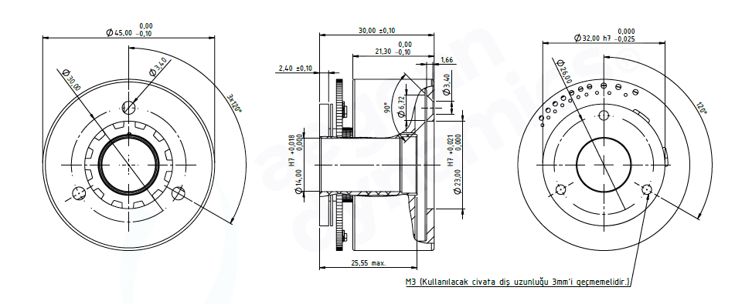
Basic Motor Parameters
Rated Power | W | 50
Rated Speed | rpm | 2200
Rated Torque | Nm | 0.22
Rated Current | A | 2.5
Rated Voltage | V | 28
No-Load Speed | rpm | 2600
Max. Efficiency | % | 90
Electrical Parameters
Number of Phases |  | 3
Number of Poles |  | 14
Torque Constant (KT) | Nm/A | 0.1
Back EMF Constant (KE) | Vs/rad | 0.1
Terminal Resistance Phase to Phase (±%10) | mΩ | 1000
Terminal Inductance Phase to Phase (±%30) | mH | 0.75
Thermal Data
Ambient Temperature | °C | -40...+85
Max. Winding Temperature | °C | +155
Physical Parameters
Outer Diameter | mm | 45
Shaft Diameter | mm | N/A
Max. Lenght | mm | 30
Weight | gr | ~500
Motor Connection
U | RED
V | WHITE
W | BLACK
Sensor Connection
NTC | PURPLE
GND | GREEN
GND | GREEN
VCC | BLUE
H1 | BROWN
H2 | YELLOW
H3 | ORANGE
Connector Articles
Power | N/A
Signal | N/A

